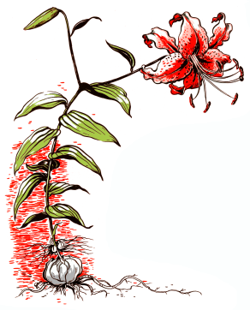
Victoria Lily Society (VLS)
2024 Membership Form

Name (s): ________________________________________________________________________________________

Address: __________________________________________________________________________________________

City: _______________________ PCode: ____________________ Phone: ________________________________

Email: _____________________________________________________________________________________________

I am a: ◻ Returning Member or ◻ New Member
Do you consent to your photo taken at Club activities be included in our Newsletter? ◻ I consent
Do you consent to your name (phone; email) be included in our shared Membership List? ◻ I consent

Do you have any particular interests? ____________________________________________________________________________

Do you have something you would like to share or speak with us about? _____________________________________

Please indicate which activities below you would like to help out with:

____ annual show (June or July) ____ meetings electronics setup
____ annual auction (October) ____ meetings coffee/sweets service
____ annual lily bulb members order ____ meetings driving/car-pooling
____ club lily bulbs stewardship / maintenance ____ meeting guest speaker suggestion
____ HCP Lily Garden maintenance roster ____ host a garden visit
____ newsletter ____ field trips
____ membership ____ library

Please make your cheque payable to the Victoria Lily Society
$20.00 Annual household membership ◻ $ _____ Cash OR ◻$ _____ Cheque OR
◻$ _____ e-transfer account victorialilysociety@gmail.com Please note from whom the payment is made.

Guests are always welcome; please bring them along.

Signature__________________________________________________________ Date_________________________________________

NOTE: To renew or join by mail send the completed Membership Form and a cheque to:
Margaret Long, 2783 Benson Place, Victoria, BC V8N 1S5 E: marglong1@gmail.com
T: 250.217.4640 This form can also be obtained at www.victorialilysociety.ca/about-us/

Victoria Lily Society is a Regional member of the North American Lily Society
Feb 2024

